ISBA 2438 Assignment 2 (Part 1): Prompt Log and Critique
Repository: GitHub - Potfolio Website
GitHub SHA:

Prompt Log

Prompt 1: Scaffold
- Create a Next.js (App Router, TypeScript) portfolio project in this repo. Pages needed: / (landing), /about-me, /projects, /projects/[slug], /contact-me-server-form.
- Add a shared navbar in a reusable component (src/components/Navbar.tsx) linking to all of them, used from the root layout. Keep styling simple (Tailwind or CSS modules). Use placeholder content for now. Don't build the contact form yet.
Result: Next.js App Router + TypeScript project created with the five routes and a reusable Navbar.tsx used from layout.tsx.
My check: ran npm run dev and clicked every nav link.

Prompt 2: Content and Dynamic Routes
- Fill in real content. Landing: name "[Your Name]", one-line headline, short intro, link to projects. About: bio, skills list, education. Projects: store projects in src/data/projects.ts as an array with slug, title, summary, description, tech, and link.
- Include three projects: "[inventory-cli]", "[multi-agent-rag-research-assistant]" and [airbnb-california-market analysis]. /projects lists them with links to /projects/[slug].
- The detail page looks up the slug and shows that project. For an unknown slug, call notFound()and add a friendly not-found.tsx with a link back to /projects. Add generateStaticParams.
Result: Real content added. Projects live in src/data/projects.ts (three projects: inventory-cli, multi-agent-rag-research-assistant airbnb-california-market-analysis). /projects/[slug] looks up the slug, and an unknown slug shows a “Project not found” page with a link back.
My check: Visited the project slugs and an unknown slug.

Prompt 3: Validation Logic
- Create src/lib/validateContact.ts exporting validateContact(input) that returns { valid, errors, data } with trimmed values. Rules: name and message must be non-blank after trimming.
- Email: no whitespace, exactly one "@", non-blank text before it, domain contains a dot,
and every dot-separated label in the domain is non-blank. Don't use a loose regex copied from
the internet. implement these rules explicitly.
- Also write a small test file covering valid input, blank/whitespace name, blank message, and emails like "a@@b.com", "a@b", "a@.com", "a@b..com", "@b.com", "a b@c.com".
Summary / result: validateContact.ts with explicit email rules and a Vitest file (9 tests at this stage).
My check: npm test passed.

Prompt 4: Server Endpoint and JSON storage
- Create the server handler for the contact form. Either a Server Action or a route handler at
src/app/api/contact-server-form/route.ts (pick one and explain why). It must call validateContact
from src/lib, return 400 with field errors on failure, and on success append { id, name, email, message, submittedAt } to data/contacts.json.
- Put file read/write in src/lib/contactStore.ts, create the file if missing, and handle a corrupt or empty file safely. Return 200/201 with a success message.
Result: Route handler src/app/api/contact-server-form/route.ts (400 with field errors, 201 on success) and src/lib/contactStore.ts that appends to data/contacts.json.
My check: Valid and invalid requests against the endpoint, and inspected data/contacts.json.
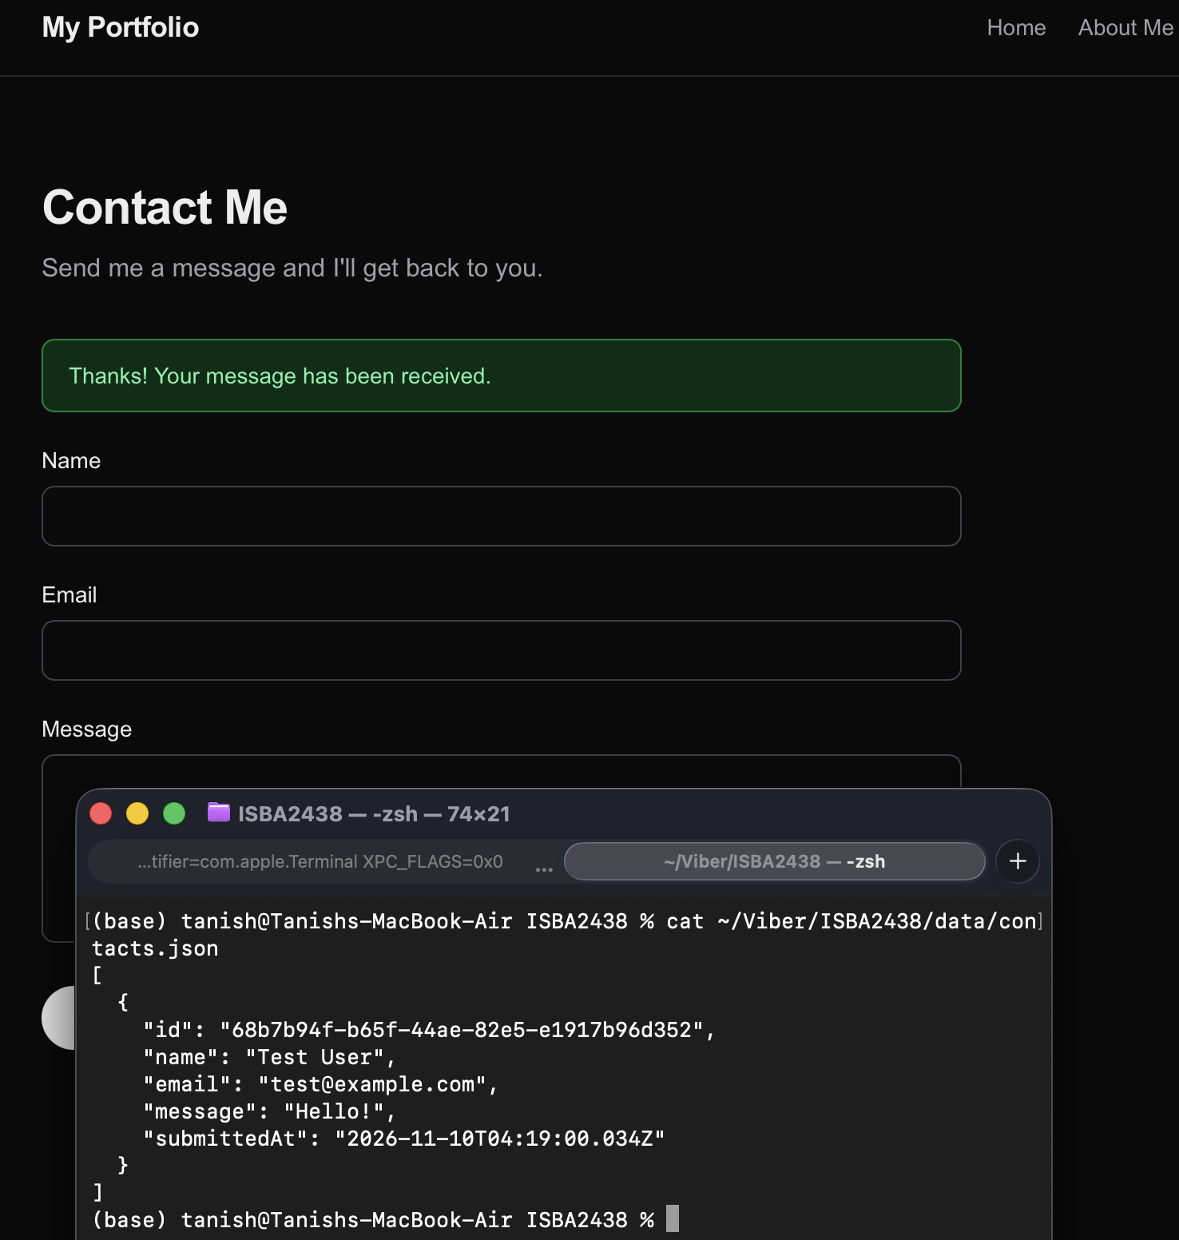

Prompt 5: Form UI
- Build /contact-me-server-form with a reusable ContactForm component in
src/components/ContactForm.tsx. Labeled fields: Name, Email, Message (use <label htmlFor>).
- On submit, send to the endpoint, show per-field validation errors, a clearly styled green
success message, and a separate red message for network/server failure.
- Disable the buttonwhile submitting and clear the form on success.
- Don't duplicate the validation rules on the client; rely on the server response.
Result: ContactForm.tsx with labeled fields, per-field errors from the server, a green success message, a red failure message, and a disabled button while submitting.
My check: Submitted valid input, blank name, a bad email, and a forced storage failure.

Prompt 6: Cleanup
- Review the project for duplicated logic, unclear names, and unused files. Make the page -> ContactForm -> endpoint -> validateContact -> contactStore flow easy to follow.
- Add a README with run instructions and a short architecture note. Don't change behavior.
Result: README with run instructions and a page table, and small cleanups.
My check: npm run build and npm test passed.

Prompt 7: Fix .gitignore and seed the data file
- In .gitignore, remove the "/data" entry under "runtime data" so data/contacts.json is tracked.
Make sure data/contacts.json contains exactly an empty JSON array: [ ] followed by a newline.
Don't change any other behavior.
Result: /data removed from .gitignore, and data/contacts.json is [ ].
My check: confirmed cat data/contacts.json prints [ ], and that the file is present in the GitHub repo.

Prompt 8: Stop silently overwriting a corrupt data file
- In src/lib/contactStore.ts, change readContacts so that a missing or empty file still returns [ ],
but a file that exists with invalid JSON, or valid JSON that isn't an array, throws an Error
instead of returning [ ]. That way appendContact fails and the route handler returns its existing
500 "Failed to save your message" response, and the bad file is never overwritten.
- Also make the write safer: write to data/contacts.json.tmp and then rename it over contacts.json.
- Add a Vitest test for contactStore that uses a temporary directory (make the data path
configurable via an optional parameter or an env var, with the default unchanged). Cover:
missing file, empty file, valid array, corrupt JSON (expect throw, file unchanged).
Result: contactStore.ts now throws on corrupt or non-array data and writes through a temp file and rename. New contactStore.test.ts; all 14 tests pass.
My check: see critique example 3.

Prompt 9: Fix the hardcoded navbar link
- In src/components/Navbar.tsx, remove the hardcoded "/projects/inventory-cli" "Inventory CLI" link.
Navigation should only link to Home, About Me, Projects, and Contact. The project detail pages
stay reachable from /projects. Don't change anything else.
Result: Navbar now has four links: Home, About Me, Projects, Contact.
My check: confirmed the four links in the nav and that each project is reachable from /projects.

Prompt 10: Remove the duplicate type
- In src/lib/validateContact.ts, ContactInput and ContactData are identical. Keep one
(ContactFields) and use it for both the input parameter and the data field. Update any imports.
Don't change behavior.
Result: ContactInput and ContactData merged into ContactFields in validateContact.ts.
My check: npm run build compiled with no errors and npm test passed (14 tests).

Prompt 11: Fix degree and program details
- Fix the degree and program details in the portfolio so they are accurate. Make these changes only: src/app/page.tsx: change the headline "Information systems student building useful software for the web." to "MS in Business Analytics student building useful software for the web."In the intro paragraph, change "I'm a student at Santa Clara University who enjoys turning ideas into working tools" so it says "I'm an MS in Business Analytics student at Santa Clara University who enjoys turning ideas into working tools". Keep the rest of the paragraph.
- src/app/about-me/page.tsx: change the bio to say "I'm Tanish Jagadheshan, an MS in Business Analytics student at Santa Clara University." Remove the sentence about hiking and pick-up basketball. Keep the rest of the bio.
- In the Education section, replace "B.S. in Information Systems — Santa Clara University" with two entries: "M.S. in Business Analytics — Santa Clara University" and "B.Tech in Electronics and Instrumentation Engineering". Don't change anything else.
Result: src/app/page.tsx and src/app/about-me/page.tsx now describe me as an MS in Business Analytics student. The Education section lists the M.S. in Business Analytics and the B.Tech in Electronics and Instrumentation Engineering. The hobbies sentence was removed. This corrected inaccurate personal details that Viber had generated in the first build.
My check: I opened / and /about-me and confirmed the new wording and that no “Information Systems” text remained. npm run build compiled successfully.

Critique of the Generated Code

Example 1: Email validation, src/lib/validateContact.ts (Prompt 3)

- What Viber proposed: hand-written rules (whitespace, exactly one @, non-empty local part, a dot in the domain, no empty domain labels) instead of one regex.
- What I decided and why: I accepted it. Each rule maps to one stated requirement and produces a specific error message, which is easier to review than a regex.
- Check and actual outcome: I ran npm test. The cases a@@b.com, a@b, a@.com, a@b..com, @b.com and a b@c.com are all rejected with the expected reason, and all 14 tests pass.
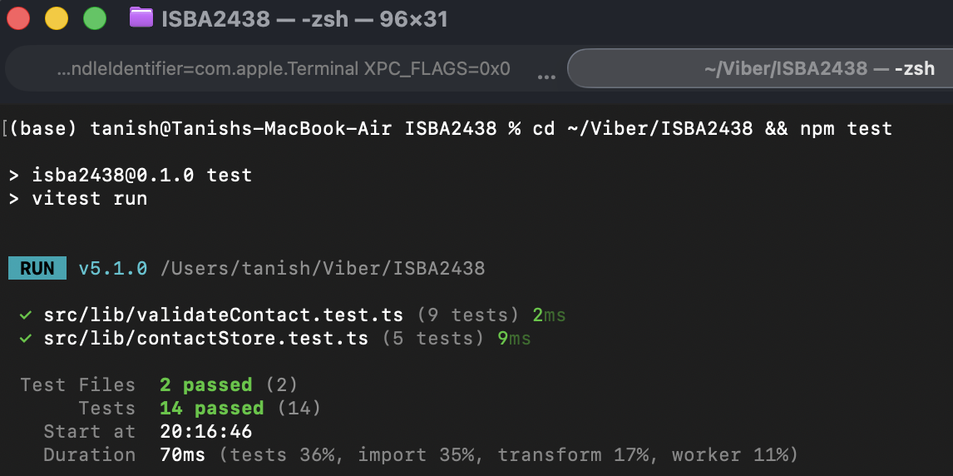

Example 2: Server-side-only validation, src/components/ContactForm.tsx and src/app/api/contact-server-form/route.ts (Prompts 4-5)

- What Viber proposed: the form sends the raw values and renders the field errors the server returns, instead of duplicating the rules on the client.
- What I decided and why: I kept it. There is one source of truth for the rules, and the server is the real gatekeeper.
- Check and actual outcome: I submitted the form in the browser with a blank Name, a@b as the Email and “Hi” as the Message. The page showed “Name is required.” under Name and “Email domain must contain a dot.” under Email, with both inputs outlined in red. Message had no error and no success banner appeared. The messages came from the server’s 400 response, not from client-side code.

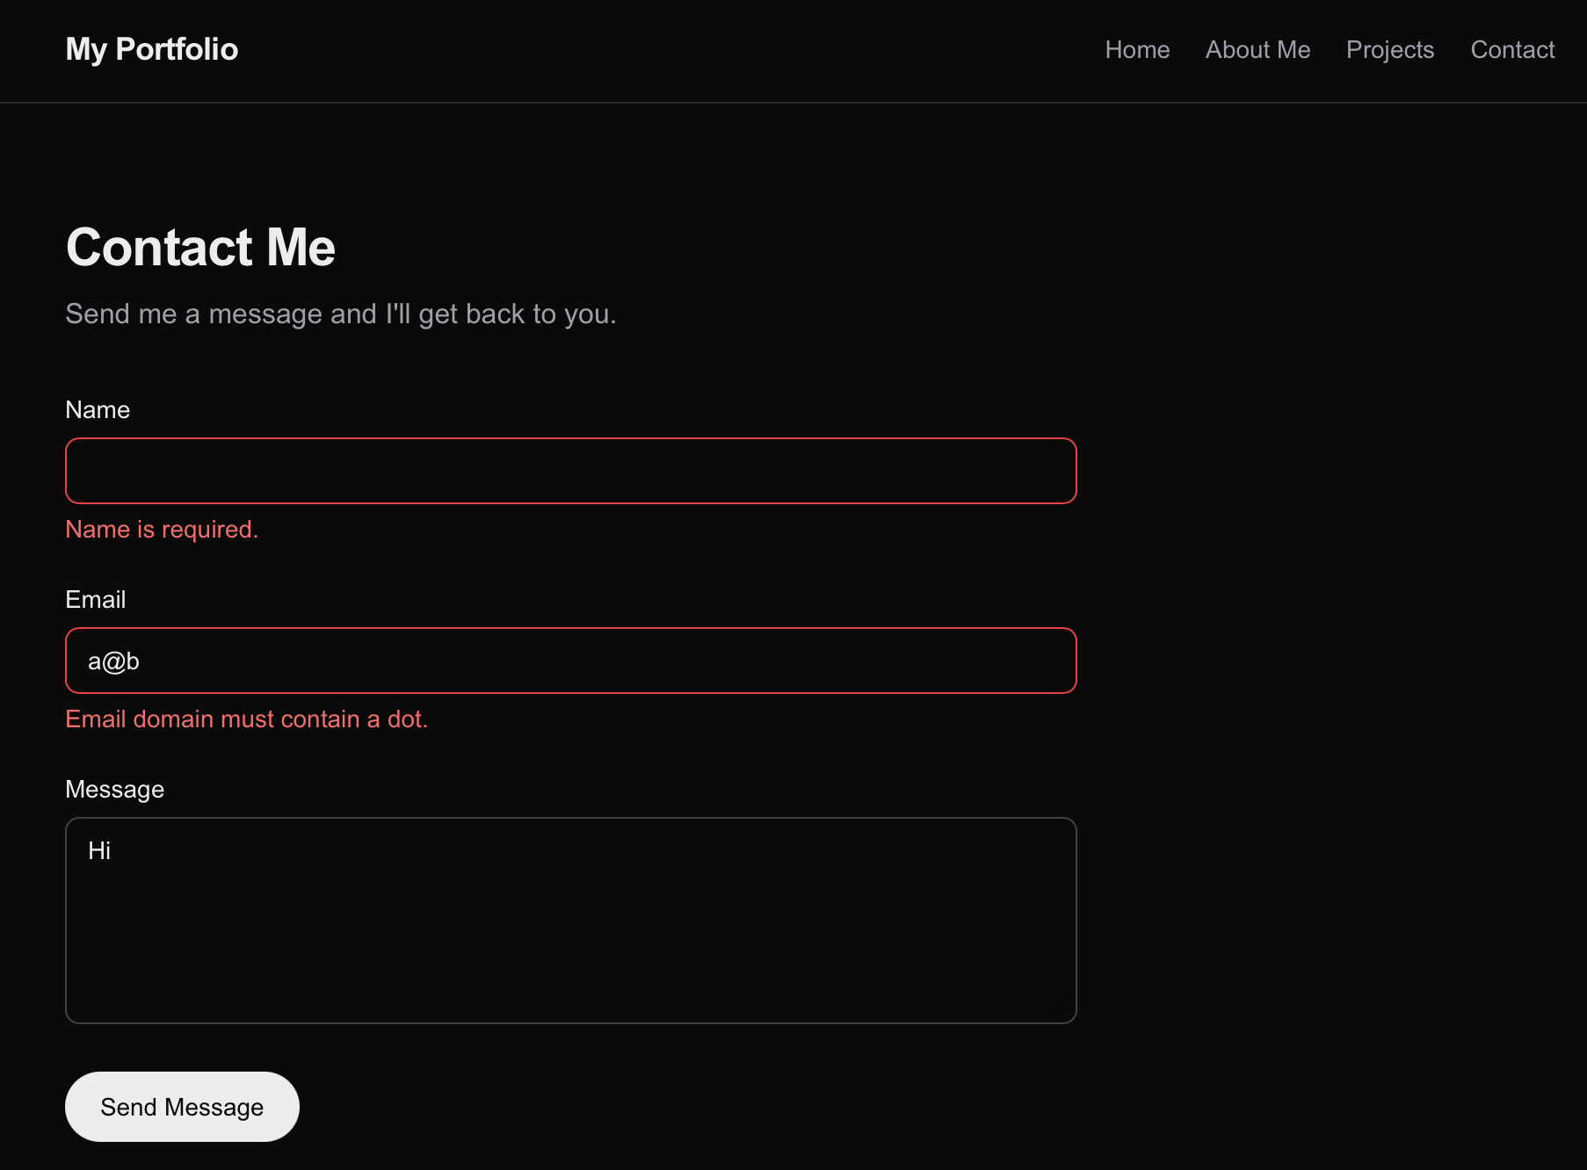

Example 3: Corrupt data file, src/lib/contactStore.ts (Prompt 8)

- Original behavior: A code review of the generated code pointed out that a corrupt JSON file was silently treated as an empty list, so the next submission would overwrite the file and lose any stored data.
- What I decided and why: I had Viber change it (Prompt 8) to throw instead, so the route returns its 500 “Failed to save your message” response, and to write through a temp file and a rename.
Check and actual outcome: I put {oops in data/contacts.json and submitted a valid form in the browser. The UI showed the red “Failed to save your message. Please try again.” banner, and cat data/contacts.json still printed {oops, so the file was not overwritten. I then restored the file to [ ].



